# Routing URL in React JS Web Apps

In react web apps, we need *routing library* to display different web page. In this tutorial, we will be using React Router (<https://reactrouter.com/>) as routing library. Because this library is most popular among react developer.

Open last project (**3. Using Material UI as Component User Interface Library**) with VS Code.

Install react router with this command:  
**npm install react-router-dom localforage match-sorter sort-by**

First, we make a simple stylesheet (CSS) to styling our page. It’s help us to make the appearance of our website more organized.  
Open and replace “**src/index.css**” with this code:

html {

    box-sizing: border-box;

}

*,

*:before,

*:after {

    box-sizing: inherit;

}

body {

    font-family: -apple-system, BlinkMacSystemFont, "Segoe UI", "Roboto",

        "Oxygen", "Ubuntu", "Cantarell", "Fira Sans", "Droid Sans",

        "Helvetica Neue", sans-serif;

    -webkit-font-smoothing: antialiased;

    -moz-osx-font-smoothing: grayscale;

}

code {

    font-family: source-code-pro, Menlo, Monaco, Consolas, "Courier New",

        monospace;

}

html,

body {

    height: 100%;

    margin: 0;

    line-height: 1.5;

    color: #121212;

}

textarea,

input,

button {

    font-size: 1rem;

    font-family: inherit;

    border: none;

    border-radius: 8px;

    padding: 0.5rem 0.75rem;

    box-shadow: 0 0px 1px hsla(0, 0%, 0%, 0.2), 0 1px 2px hsla(0, 0%, 0%, 0.2);

    background-color: white;

    line-height: 1.5;

    margin: 0;

}

button {

    color: #3992ff;

    font-weight: 500;

}

textarea:hover,

input:hover,

button:hover {

    box-shadow: 0 0px 1px hsla(0, 0%, 0%, 0.6), 0 1px 2px hsla(0, 0%, 0%, 0.2);

}

button:active {

    box-shadow: 0 0px 1px hsla(0, 0%, 0%, 0.4);

    transform: translateY(1px);

}

#contact h1 {

    display: flex;

    align-items: flex-start;

    gap: 1rem;

}

#contact h1 form {

    display: flex;

    align-items: center;

    margin-top: 0.25rem;

}

#contact h1 form button {

    box-shadow: none;

    font-size: 1.5rem;

    font-weight: 400;

    padding: 0;

}

#contact h1 form button[value="true"] {

    color: #a4a4a4;

}

#contact h1 form button[value="true"]:hover,

#contact h1 form button[value="false"] {

    color: #eeb004;

}

form[action$="destroy"] button {

    color: #f44250;

}

.sr-only {

    position: absolute;

    width: 1px;

    height: 1px;

    padding: 0;

    margin: -1px;

    overflow: hidden;

    clip: rect(0, 0, 0, 0);

    white-space: nowrap;

    border-width: 0;

}

#root {

    display: flex;

    height: 100%;

    width: 100%;

}

#sidebar {

    width: 22rem;

    background-color: #f7f7f7;

    border-right: solid 1px #e3e3e3;

    display: flex;

    flex-direction: column;

}

#sidebar > * {

    padding-left: 2rem;

    padding-right: 2rem;

}

#sidebar h1 {

    font-size: 1rem;

    font-weight: 500;

    display: flex;

    align-items: center;

    margin: 0;

    padding: 1rem 2rem;

    border-top: 1px solid #e3e3e3;

    order: 1;

    line-height: 1;

}

#sidebar > div {

    display: flex;

    align-items: center;

    gap: 0.5rem;

    padding-top: 1rem;

    padding-bottom: 1rem;

    border-bottom: 1px solid #e3e3e3;

}

#sidebar > div form {

    position: relative;

}

@keyframes spin {

    from {

        transform: rotate(0deg);

    }

    to {

        transform: rotate(360deg);

    }

}

#sidebar nav {

    flex: 1;

    overflow: auto;

    padding-top: 1rem;

}

#sidebar nav a span {

    float: right;

    color: #eeb004;

}

#sidebar nav a.active span {

    color: inherit;

}

i {

    color: #818181;

}

#sidebar nav .active i {

    color: inherit;

}

#sidebar ul {

    padding: 0;

    margin: 0;

    list-style: none;

}

#sidebar li {

    margin: 0.25rem 0;

}

#sidebar nav a {

    display: flex;

    align-items: center;

    justify-content: space-between;

    overflow: hidden;

    white-space: pre;

    padding: 0.5rem;

    border-radius: 8px;

    color: inherit;

    text-decoration: none;

    gap: 1rem;

}

#sidebar nav a:hover {

    background: #e3e3e3;

}

#sidebar nav a.active {

    background: hsl(224, 98%, 58%);

    color: white;

}

#sidebar nav a.pending {

    color: hsl(224, 98%, 58%);

}

#detail {

    flex: 1;

    padding: 2rem 4rem;

    width: 100%;

}

#detail.loading {

    opacity: 0.25;

    transition: opacity 200ms;

    transition-delay: 200ms;

}

#contact {

    max-width: 40rem;

    display: flex;

}

#contact h1 {

    font-size: 2rem;

    font-weight: 700;

    margin: 0;

    line-height: 1.2;

}

#contact h1 + p {

    margin: 0;

}

#contact h1 + p + p {

    white-space: break-spaces;

}

#contact h1:focus {

    outline: none;

    color: hsl(224, 98%, 58%);

}

#contact a[href*="twitter"] {

    display: flex;

    font-size: 1.5rem;

    color: #3992ff;

    text-decoration: none;

}

#contact a[href*="twitter"]:hover {

    text-decoration: underline;

}

#contact img {

    width: 12rem;

    height: 12rem;

    background: #c8c8c8;

    margin-right: 2rem;

    border-radius: 1.5rem;

    object-fit: cover;

}

#contact h1 ~ div {

    display: flex;

    gap: 0.5rem;

    margin: 1rem 0;

}

#contact-form {

    display: flex;

    max-width: 40rem;

    flex-direction: column;

    gap: 1rem;

}

#contact-form > p:first-child {

    margin: 0;

    padding: 0;

}

#contact-form > p:first-child > :nth-child(2) {

    margin-right: 1rem;

}

#contact-form > p:first-child,

#contact-form label {

    display: flex;

}

#contact-form p:first-child span,

#contact-form label span {

    width: 8rem;

}

#contact-form p:first-child input,

#contact-form label input,

#contact-form label textarea {

    flex-grow: 2;

}

#contact-form-avatar {

    margin-right: 2rem;

}

#contact-form-avatar img {

    width: 12rem;

    height: 12rem;

    background: hsla(0, 0%, 0%, 0.2);

    border-radius: 1rem;

}

#contact-form-avatar input {

    box-sizing: border-box;

    width: 100%;

}

#contact-form p:last-child {

    display: flex;

    gap: 0.5rem;

    margin: 0 0 0 8rem;

}

#contact-form p:last-child button[type="button"] {

    color: inherit;

}

#zero-state {

    margin: 2rem auto;

    text-align: center;

    color: #818181;

}

#zero-state a {

    color: inherit;

}

#zero-state a:hover {

    color: #121212;

}

#zero-state:before {

    display: block;

    margin-bottom: 0.5rem;

}

#error-page {

    display: flex;

    flex-direction: column;

    align-items: center;

    justify-content: center;

    width: 100%;

}

Create folder “**routes**” inside “**src**” folder

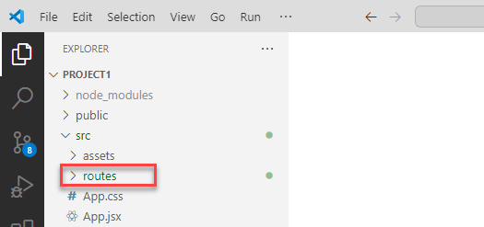

Create 3 files inside routes folder:

* **root.jsx**
* **page1.jsx**
* **page2.jsx**

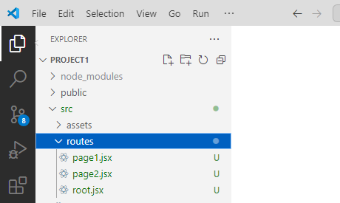

Open and put this code in **src/routes/root.jsx**:

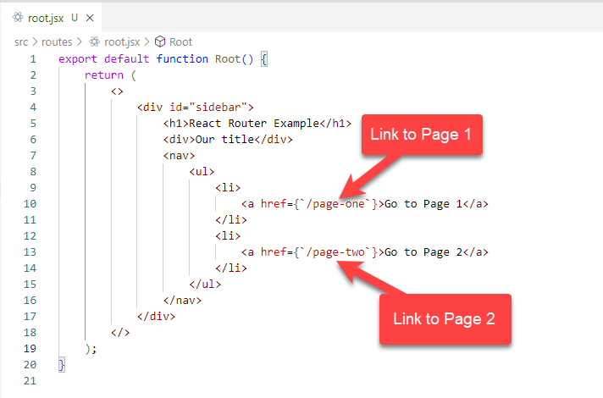  
export default function Root() {

    return (

        <>

            <div id="sidebar">

                <h1>React Router Example</h1>

                <div>Our title</div>

                <nav>

                    <ul>

                        <li>

                            <a href={`/page-one`}>Go to Page 1</a>

                        </li>

                        <li>

                            <a href={`/page-two`}>Go to Page 2</a>

                        </li>

                    </ul>

                </nav>

            </div>

        </>

    );

}

Open and put this code in **src/routes/page1.jsx**:  
export default function Page1() {

    return (

        <div>

            <h1>Page One</h1>

            <img

                width={300}

                src="https://www.roomie.id/img/hotel/2024/01/31/GyxVTFW9gk73S2ZzS8Mv660BGuPhuGXi.jpg"

            />

            <br></br>

        </div>

    );

}

Open and put this code in **src/routes/page2.jsx**:

export default function Page3() {

    return (

        <div>

            <h1>Page Two</h1>

            <img

                width={300}

                src="https://www.roomie.id/img/hotel/2024/01/31/room3.jpg"

            />

            <br></br>

        </div>

    );

}

Open and replace **src/main.jsx** with this code:

import * as React from "react";

import * as ReactDOM from "react-dom/client";

import { createBrowserRouter, RouterProvider } from "react-router-dom";

import "./index.css";

import Root from "./routes/root";

import Page1 from "./routes/page1";

import Page2 from "./routes/page2";

const router = createBrowserRouter([

    {

        path: "/",

        element: <Root />,

    },

    {

        path: "page-one",

        element: <Page1 />,

    },

    {

        path: "page-two",

        element: <Page2 />,

    },

]);

ReactDOM.createRoot(document.getElementById("root")).render(

    <React.StrictMode>

        <RouterProvider router={router} />

    </React.StrictMode>

);

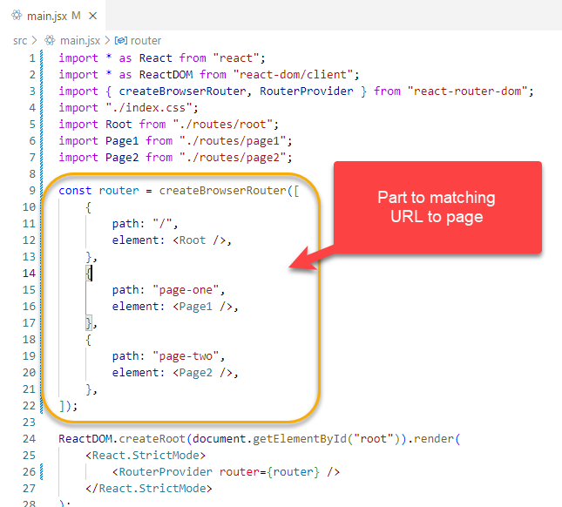

Save all files and check result in browser

Root (Home)

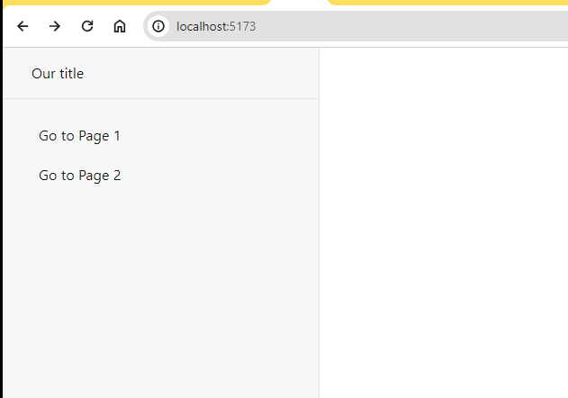

Page 1  
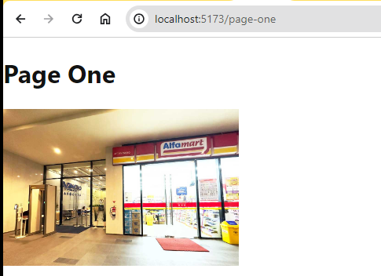

Page 2  
 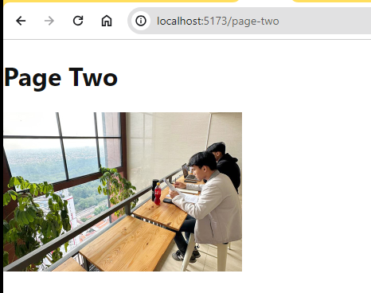

Next step, we want to display page1 and page2 inside root component.  
Open **src/main.jsx**Replace :  
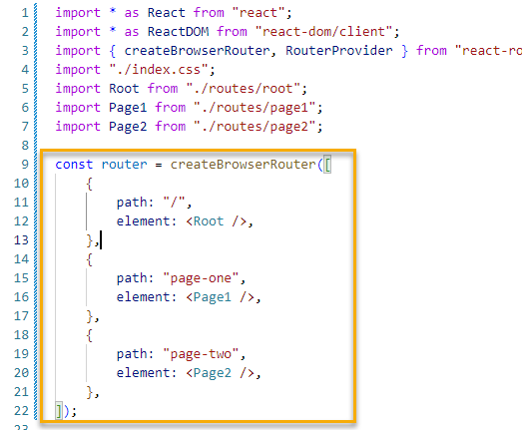

With :

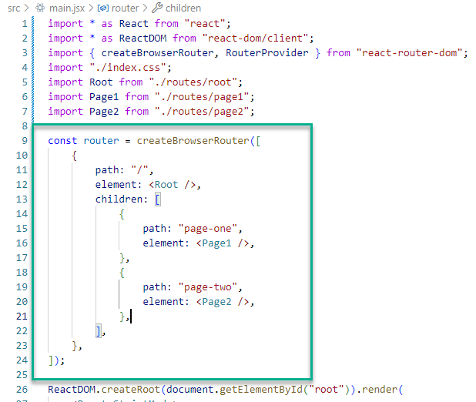

Basically, what we do is put page1 and page2 inside root children.

Insert outlet in **src/routes/root.jsx** with this code:  
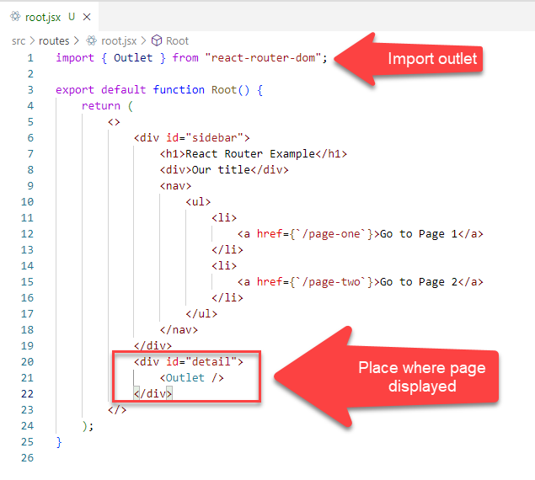

Save all files and if nothing error happened, this is your web page result:  
